C:\Users\Family\git\jenkins-build-deploy-nodejs-with-docker-app>git –version 

C:\Users\Family\git\jenkins-build-deploy-nodejs-with-docker-app>where git  
🡪 C:\Users\Family\AppData\Local\Programs\Git\cmd\git.exe



C:\Users\Family\git\jenkins-build-deploy-nodejs-with-docker-app>where cmd  
C:\Windows\System32\cmd.exe



C:\Program Files\Jenkins>where java

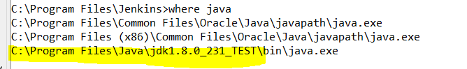

C:\Program Files\Jenkins>where mvn  
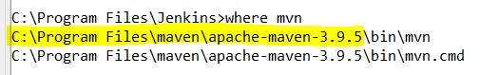

**START JENKINS**

**HOW TO START, RESTART, STOP Jenkins on Window 10**

I have extracted zip file and installed Jenkins on Windows 10 successfully.   
Jenkins runs at http://localhost:8080/ well.   
How can I do that? What's the way to start, restart and stop through console/command line?

On Windows, open Console/Command line --> Go to your Jenkins installation directory (very likely cd "C:\Program Files\Jenkins\"). Execute the following commands respectively:

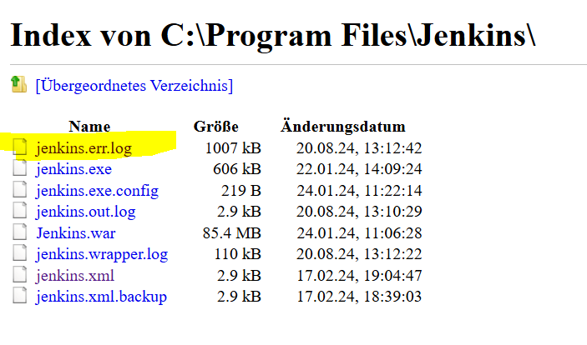

**cd C:\Program Files\Jenkins\**

**to stop:  
.\jenkins.exe stop**

**to start:  
.\jenkins.exe start**

**to restart:  
.\jenkins.exe restart**

Jenkins start

C:\Users\Family\git\jenkins-demo-with-node-js-react-npm-app>cd C:\Program Files\Jenkins  
C:\Program Files\Jenkins>dir

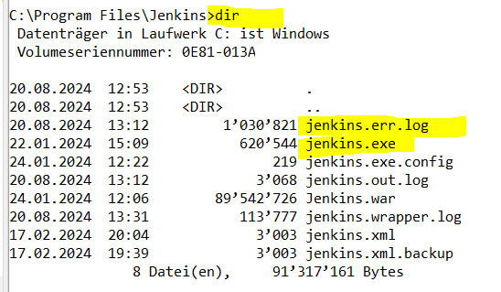

C:\Program Files\Jenkins>.\jenkins.exe start



* <http://localhost:8080/login?from=%2F>

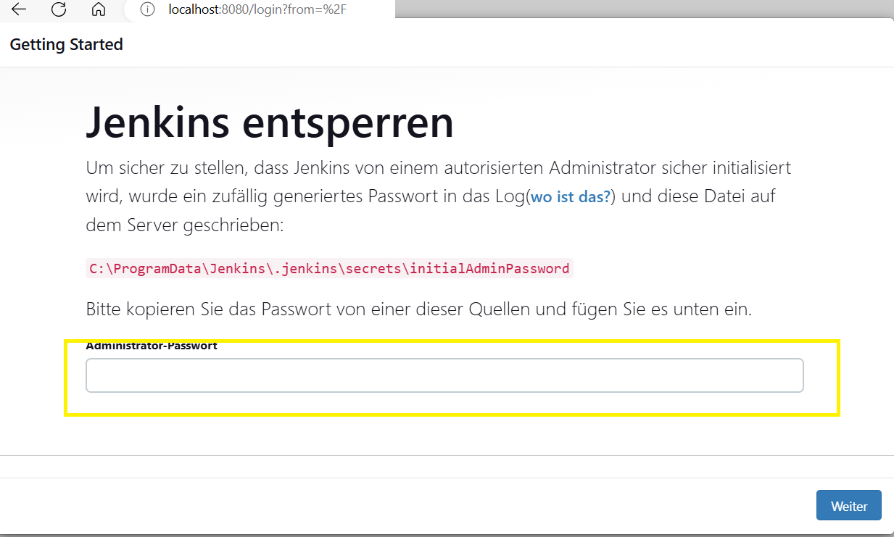



In Jenkins.err.log file contains the Jenkins login password as shown below:

Jenkins initial setup is required. An admin user has been created and a password generated.  
Please use the following password to proceed to installation:  
c51a111bd6fe414f9ccfd15848e72ef9

This may also be found at: C:\ProgramData\Jenkins\.jenkins\secrets\initialAdminPassword

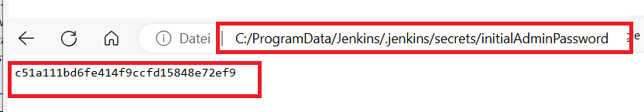

On browser 🡪 localhost:8080

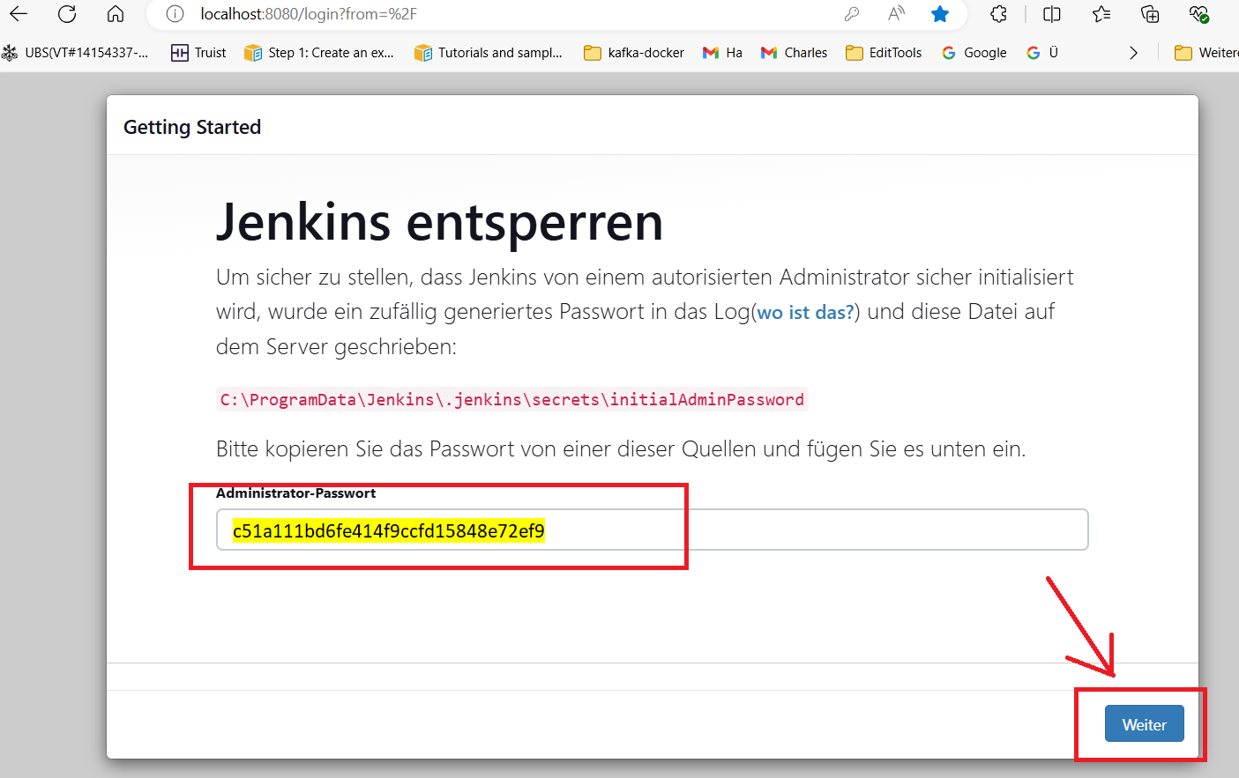

Jenkins 🡪 Getting Started page shows.

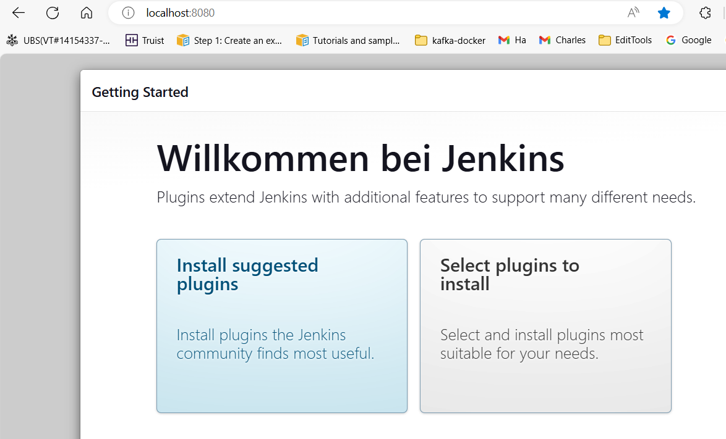

Click 🡪 Install suggested plugins

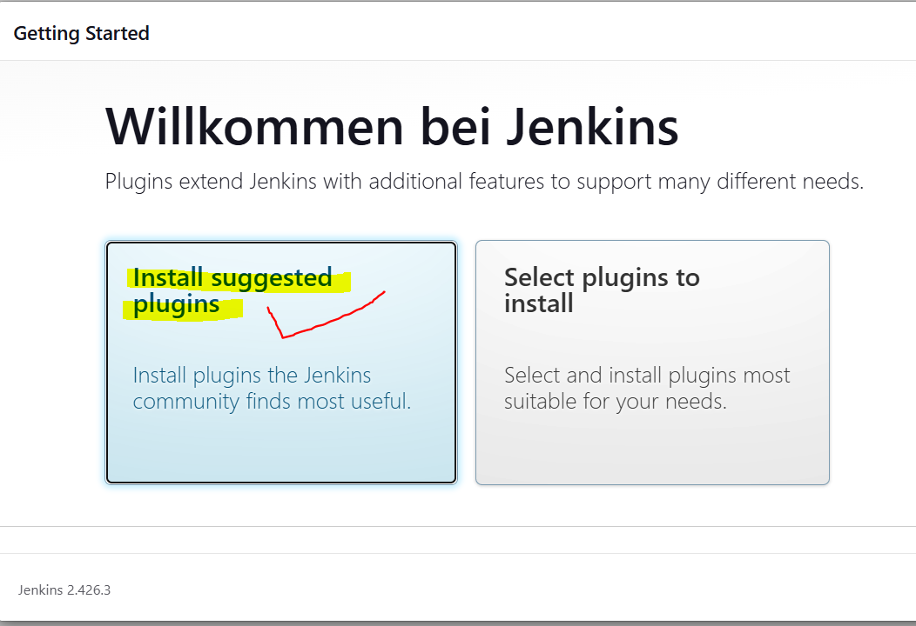

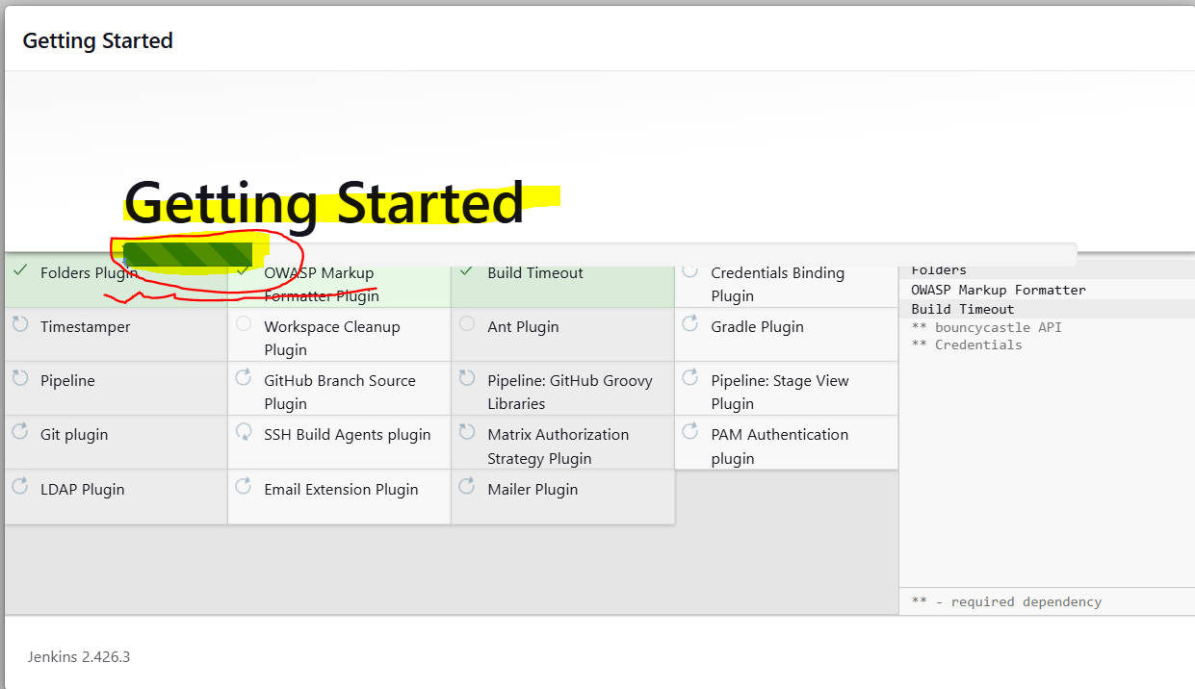

Give 🡪 UserID=admin and Password=admin and then click 🡪 “Save and Continue”-Button.

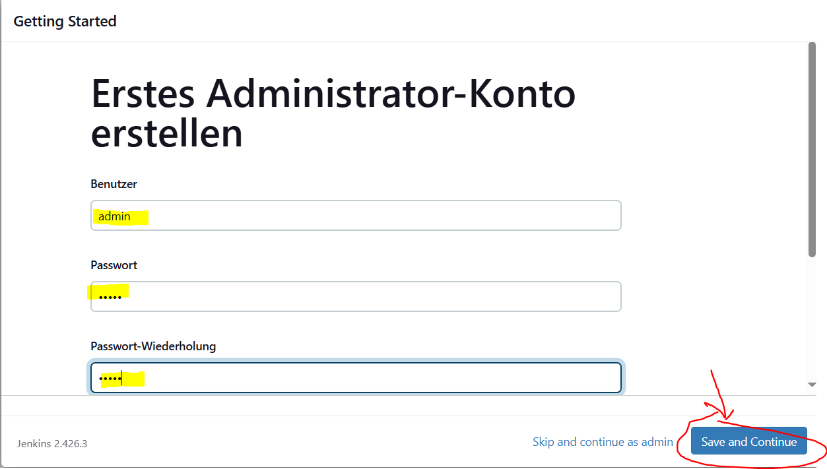

Forget E-mail Address 🡪 Give 🡪Email and then click 🡪 “Save and Continue”-Button.

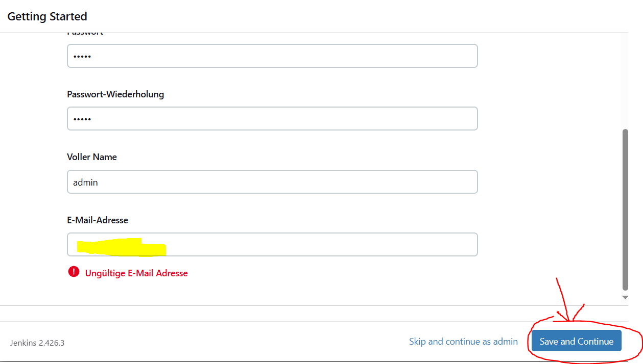

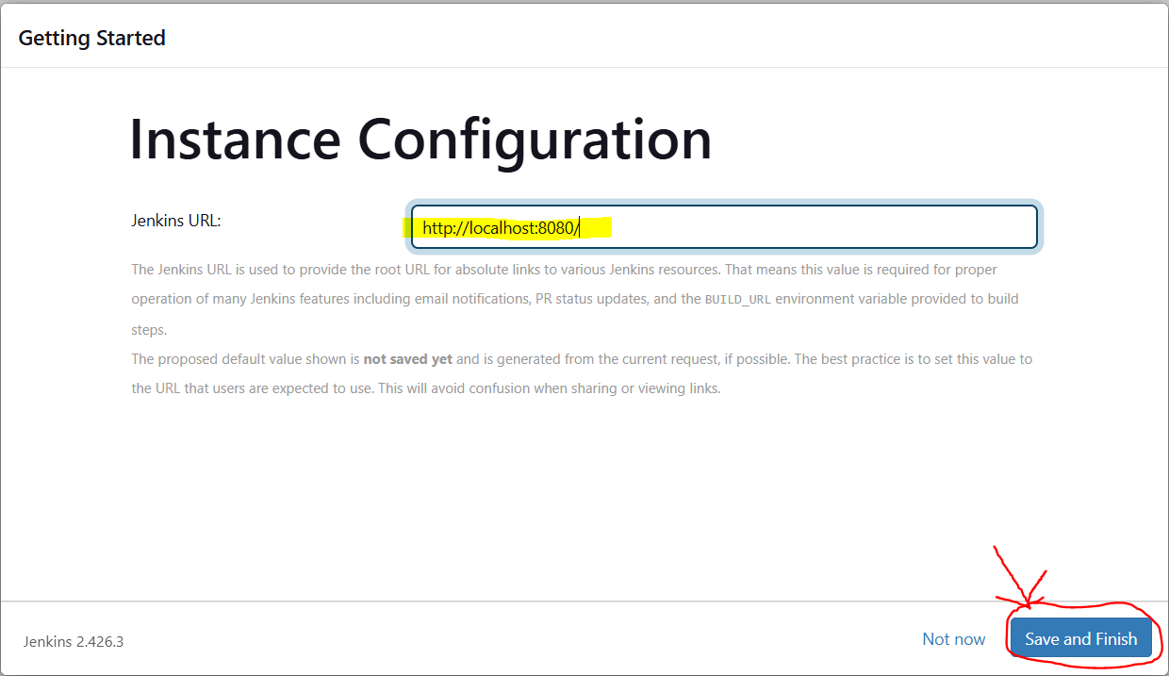

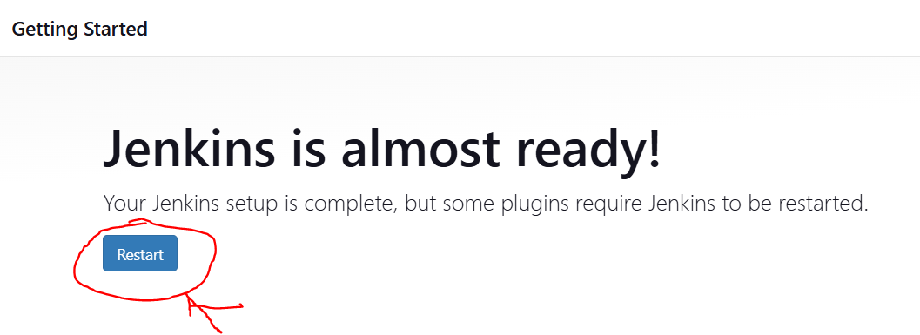

Jenkins 🡪 Restart

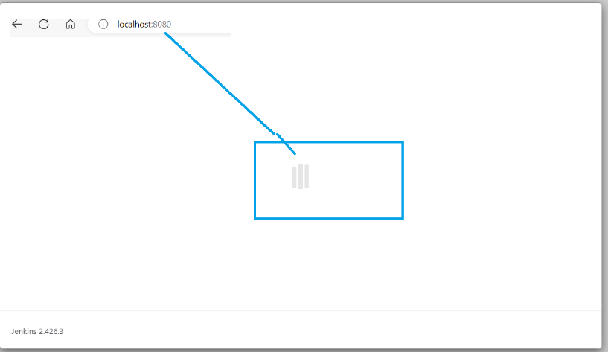

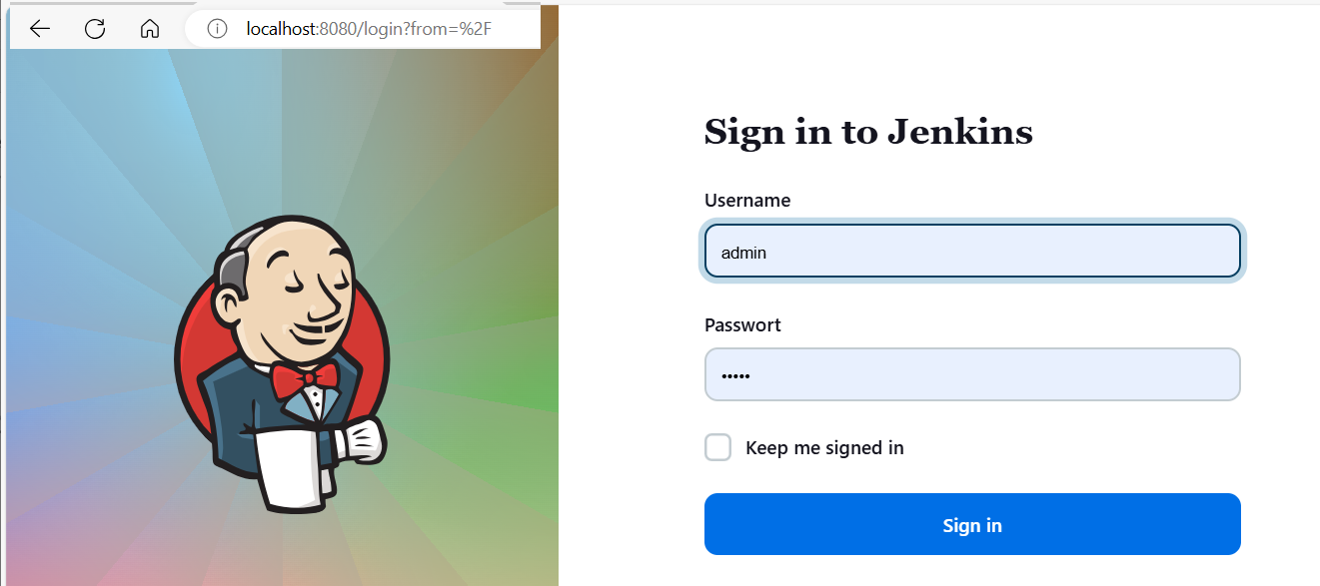

Username=admin and Password=admin 🡪 Click Sign in

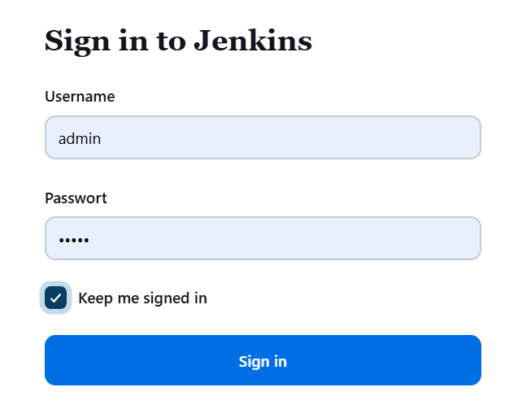

Successful 🡪 Jenkins welcome page shows.

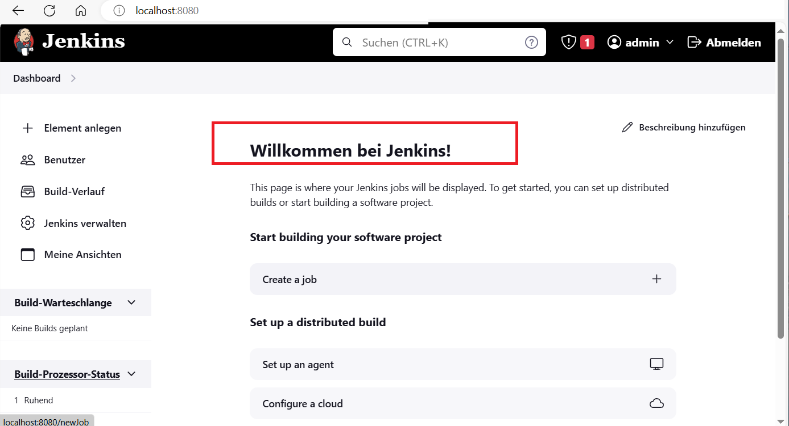

STOP Jenkins

C:\Program Files\Jenkins>.\jenkins.exe stop



<http://localhost:8080/> 🡪 shows that the connection is broken. 🡪 OK

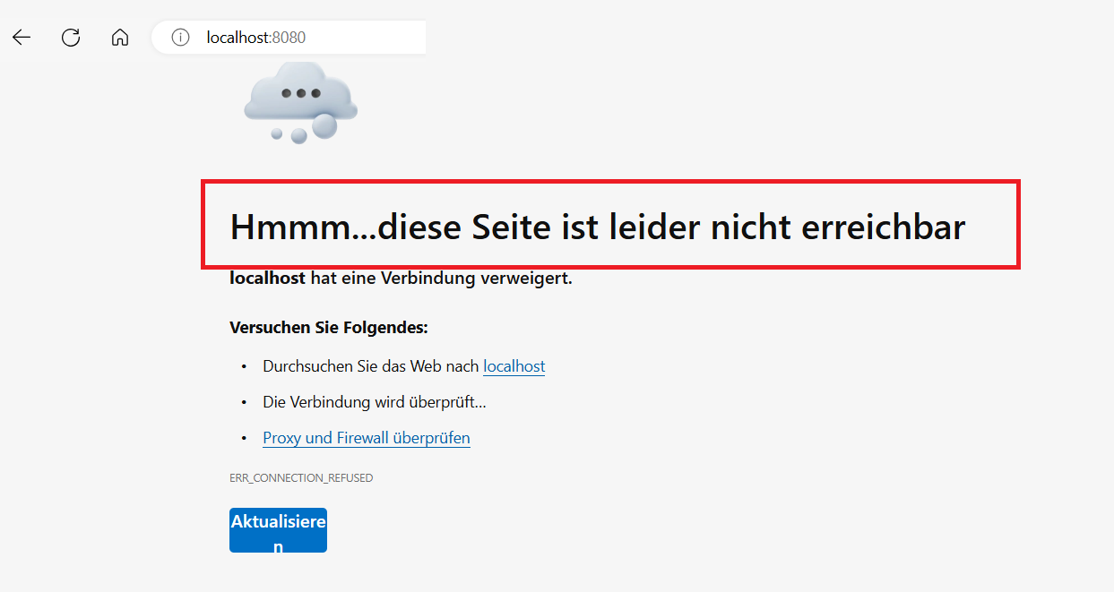

Start Jenkins 🡪 C:\Program Files\Jenkins>.\jenkins.exe start  
and login Jenkins 🡪 Jenkins open as shown below.

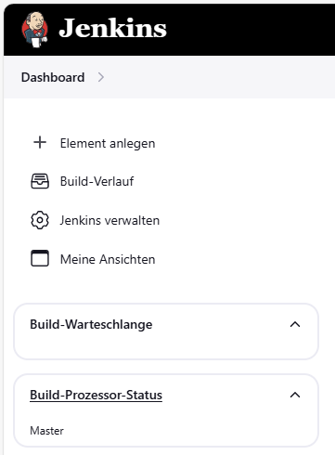

Jenkins 🡪 Build Spring Boot app

* Building Spirng Boot app without docker
* Add new element

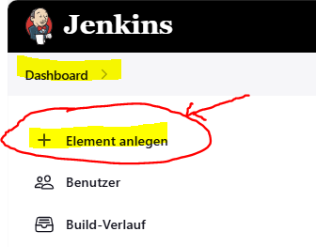 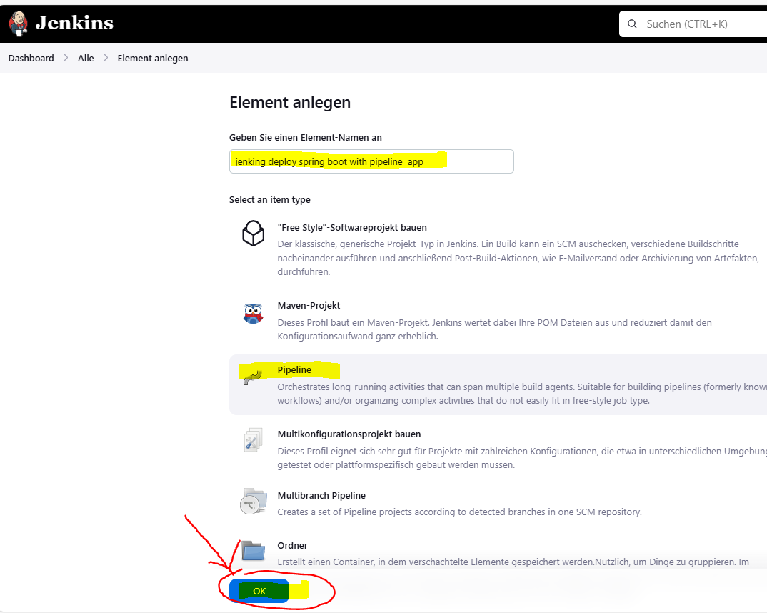

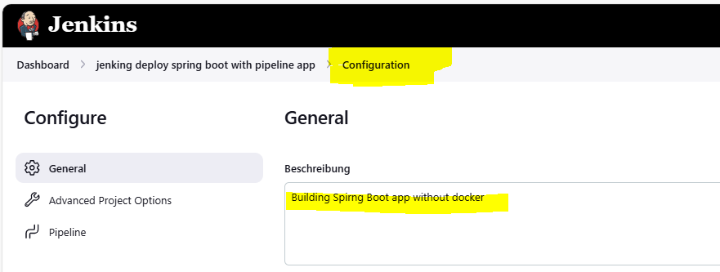

GitHub 🡪 <https://github.com/charleshoanduong1111/create-new-maven-springboot-rest-h2-jpa-webapp-for-beginners.git>

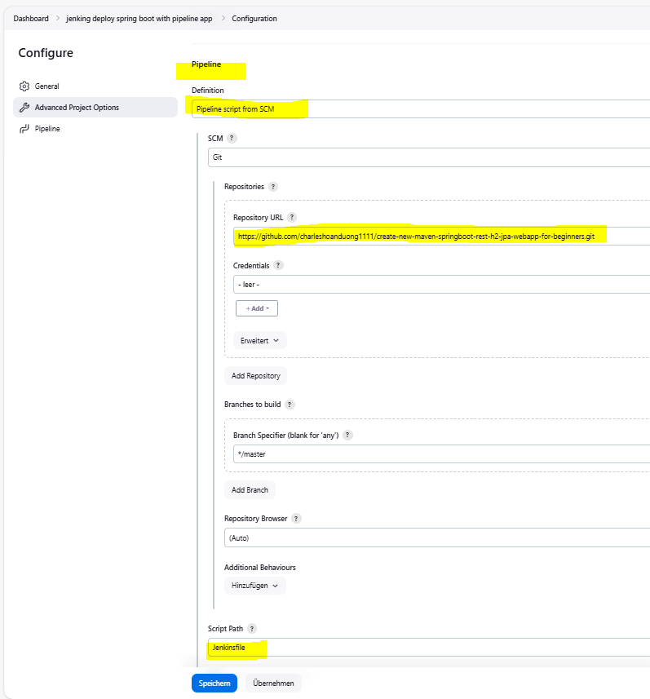

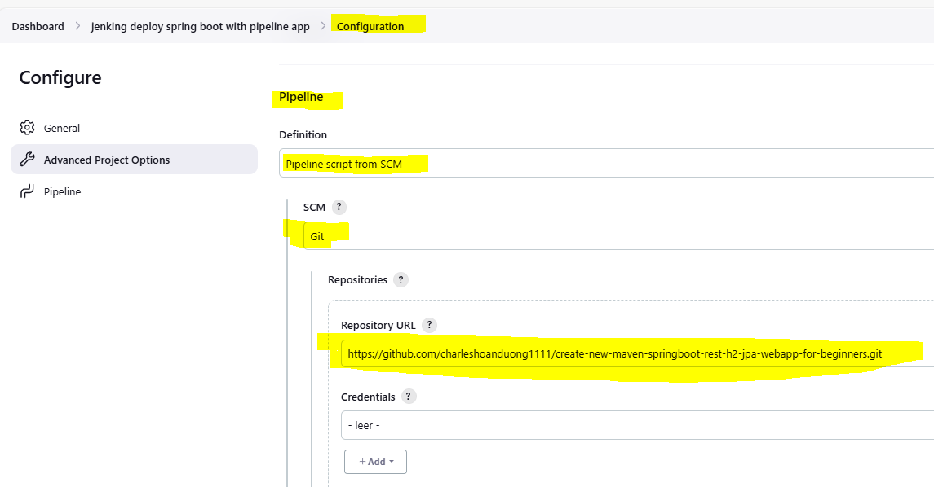

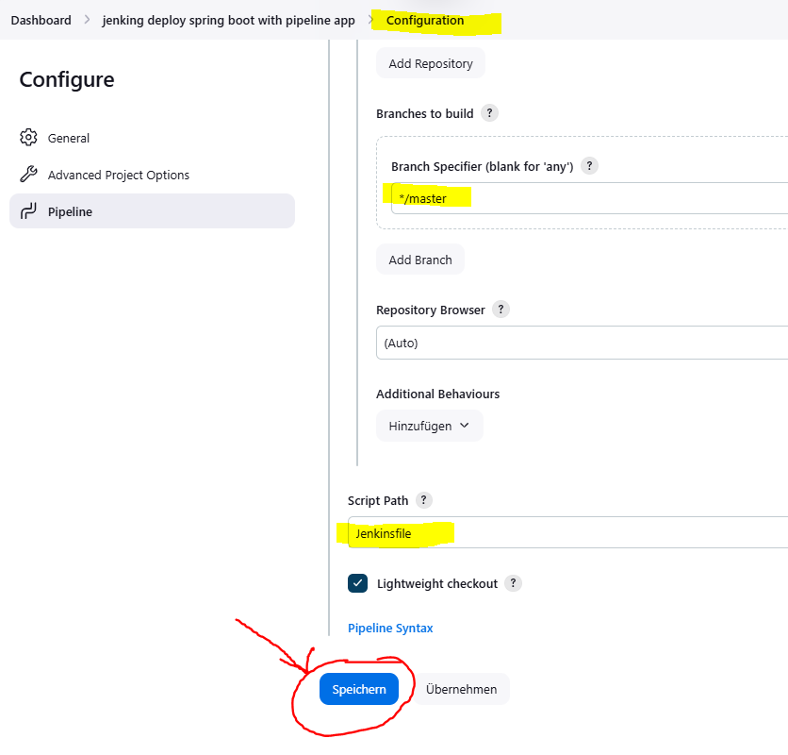

Click 🡪 Save-button

Jenkinsfile 🡪

<https://github.com/charleshoanduong1111/create-new-maven-springboot-rest-h2-jpa-webapp-for-beginners> **Jenkinsfile**

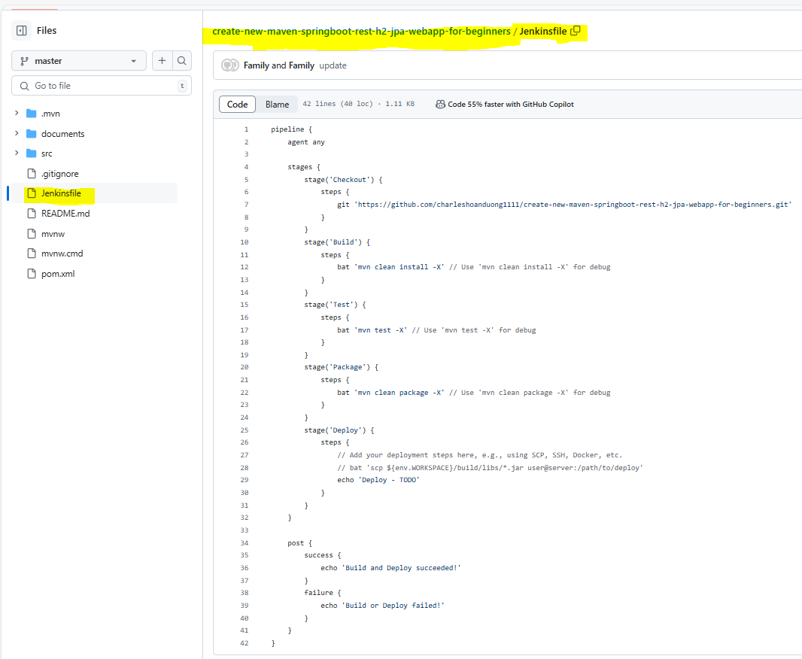

<https://github.com/charleshoanduong1111/create-new-maven-springboot-rest-h2-jpa-webapp-for-beginners> **Jenkinsfile**

pipeline {

agent any

stages {

stage('Checkout') {

steps {

git 'https://github.com/charleshoanduong1111/create-new-maven-springboot-rest-h2-jpa-webapp-for-beginners.git'

}

}

stage('Build') {

steps {

bat 'mvn clean install -X' // Use 'mvn clean install -X' for debug

}

}

stage('Test') {

steps {

bat 'mvn test -X' // Use 'mvn test -X' for debug

}

}

stage('Package') {

steps {

bat 'mvn clean package -X' // Use 'mvn clean package -X' for debug

}

}

stage('Deploy') {

steps {

echo 'Deploy - TODO'

}

}

}

post {

success {

echo 'Build and Deploy succeeded!'

}

failure {

echo 'Build or Deploy failed!'

}

}

}

JDK and Maven Tools for running Maven command  
🡪 mvn clean install 🡪 mvn clean package …

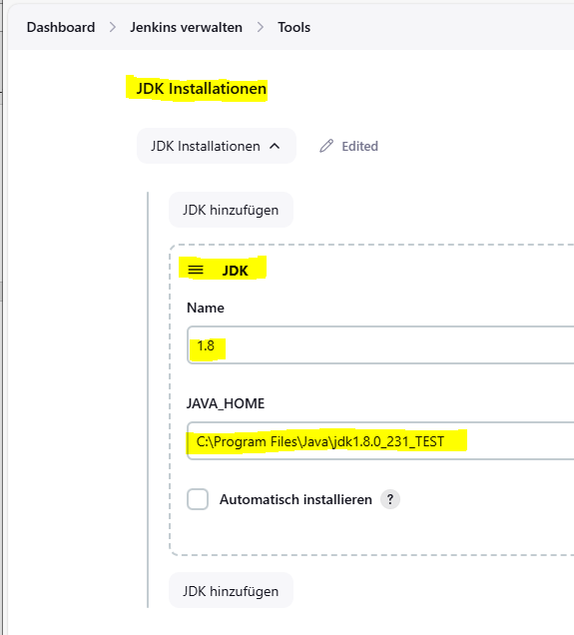

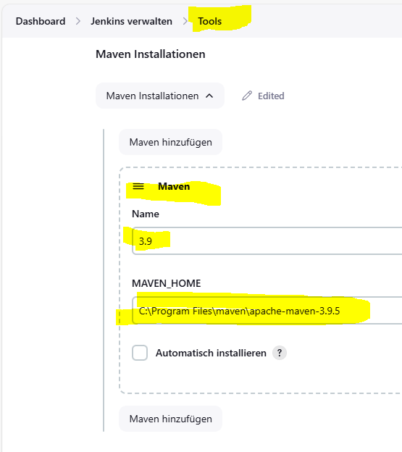

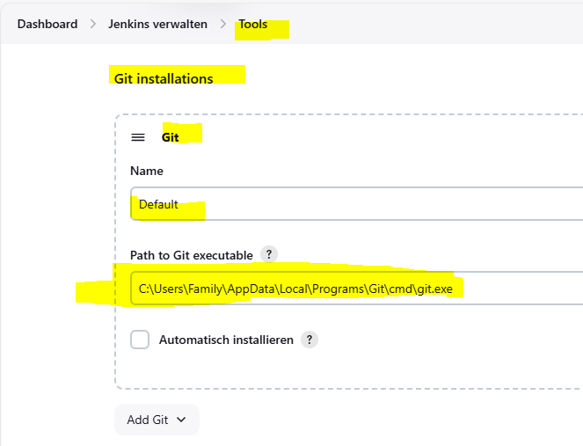

After clicking Save-button. The project is saved. Click the “**Build Now**” button as shown below.

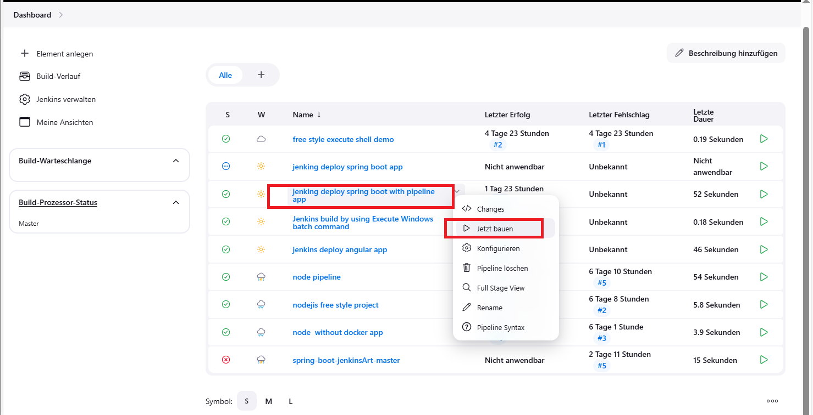

The Build is ok

